Example: Inheritance in Local classes and Polymorphism (Method overriding) in Local classes
REPORT Z1030OOPS14.
class lcl_vehicle DEFINITION.
public SECTION.
methods display.
PROTECTED SECTION.
data : wheels type i,
brakes type i.
endclass.
class lcl_vehicle IMPLEMENTATION.
method display.
write :/ wheels,brakes.
endmethod.
endclass.
class lcl_cycle DEFINITION INHERITING FROM lcl_vehicle.
PUBLIC SECTION.
methods setcycle.
* methods display. "syntax error
methods display REDEFINITION.
PROTECTED SECTION.
data color type string.
* data wheels type i.
* data brakes type i.
endclass.
class lcl_cycle IMPLEMENTATION.
method setcycle.
color = 'Green'.
wheels = 2.
brakes = 2.
endmethod.
method display.
call method super->display.
write :/ color.
endmethod.
endclass.
class lcl_bike DEFINITION INHERITING FROM lcl_cycle.
PUBLIC SECTION.
methods setbike.
methods display REDEFINITION.
PROTECTED SECTION.
data gears type i.
endclass.
class lcl_bike IMPLEMENTATION.
method setbike.
wheels = 2.
brakes = 2.
color = 'Red'.
gears = 5.
endmethod.
method display.
call method super->display.
write :/ gears.
endmethod.
endclass.
start-of-SELECTION.
write :/ '....CYCLE class object ob....'.
data ob type ref to lcl_cycle.
create object ob.
call method ob->setcycle.
call method ob->display.
uline.
write :/ '....BIKE class object ob1....'.
data ob1 type ref to lcl_bike.
create object ob1.
call method ob1->setbike.
call method ob1->display.
Example: Final Keyword
REPORT Z1030OOPS15.
*class lcl_vehicle DEFINITION final. "cannot be inherited
class lcl_vehicle DEFINITION.
public SECTION.
methods display.
methods m1 final.
* class-METHODS m2 final. "syntax error
class-METHODS m2.
PROTECTED SECTION.
data : wheels type i,
brakes type i.
endclass.
class lcl_vehicle IMPLEMENTATION.
method m1.
write :/ 'Inside instance method m1 of vehicle class..'.
endmethod.
method m2.
write :/ 'Inside static method m2 of vehicle class..'.
endmethod.
method display.
write :/ wheels,brakes.
endmethod.
endclass.
class lcl_cycle DEFINITION INHERITING FROM lcl_vehicle.
PUBLIC SECTION.
methods setcycle.
* methods display. "syntax error
methods display REDEFINITION.
* methods m1 REDEFINITION. "syntax error
PROTECTED SECTION.
data color type string.
* data wheels type i.
* data brakes type i.
endclass.
class lcl_cycle IMPLEMENTATION.
method setcycle.
color = 'Green'.
wheels = 2.
brakes = 2.
endmethod.
method display.
call method super->display.
write :/ color.
endmethod.
endclass.
class lcl_bike DEFINITION INHERITING FROM lcl_cycle.
PUBLIC SECTION.
methods setbike.
methods display REDEFINITION.
PROTECTED SECTION.
data gears type i.
endclass.
class lcl_bike IMPLEMENTATION.
method setbike.
wheels = 2.
brakes = 2.
color = 'Red'.
gears = 5.
endmethod.
method display.
call method super->display.
write :/ gears.
endmethod.
endclass.
start-of-SELECTION.
write :/ '....CYCLE class object ob....'.
data ob type ref to lcl_cycle.
create object ob.
call method ob->setcycle.
call method ob->display.
call method ob->m1.
uline.
write :/ '....BIKE class object ob1....'.
data ob1 type ref to lcl_bike.
create object ob1.
call method ob1->setbike.
call method ob1->display.

Example: Inheritance in Global classes and Polymorphism (Method overriding) in Global classes
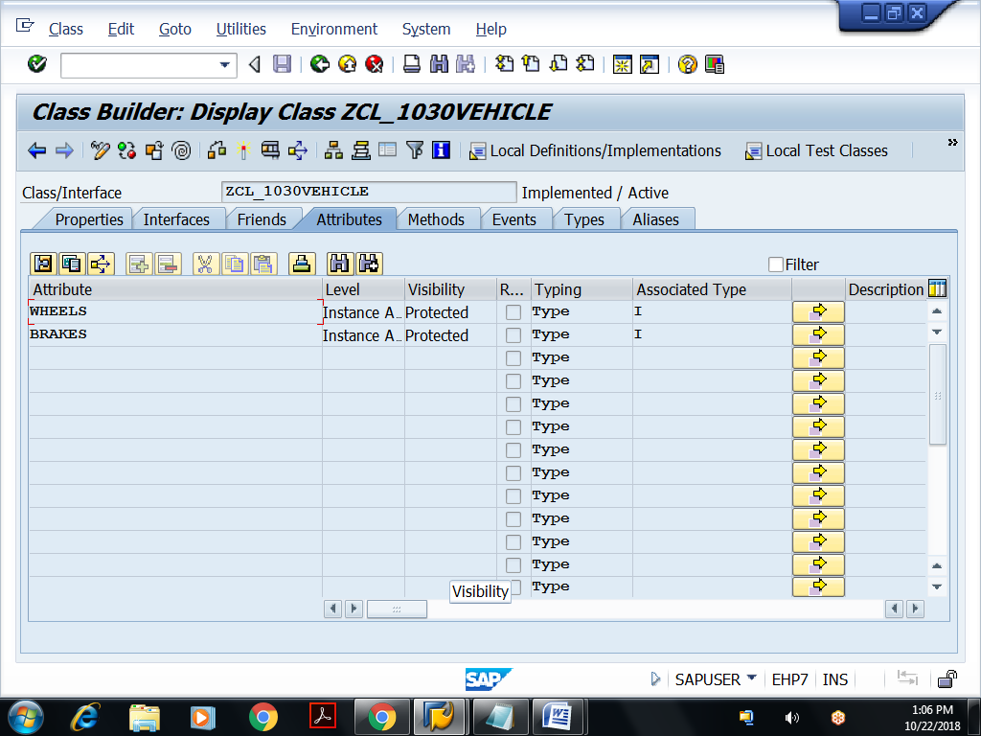
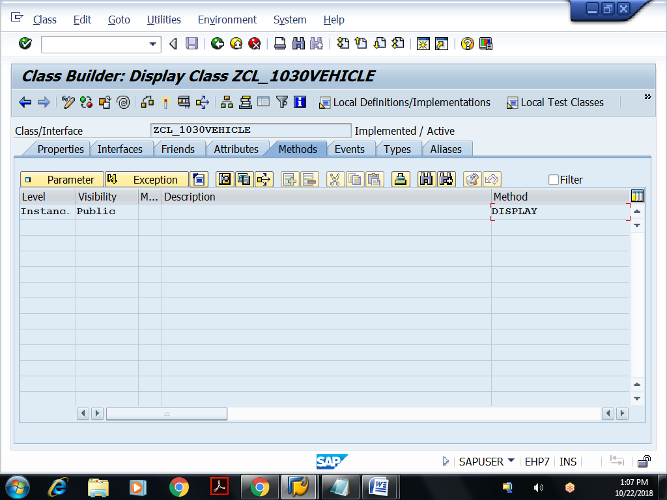
Implementation for Display method
method DISPLAY.
write :/ wheels,brakes.
endmethod.
Save, check and activate the class
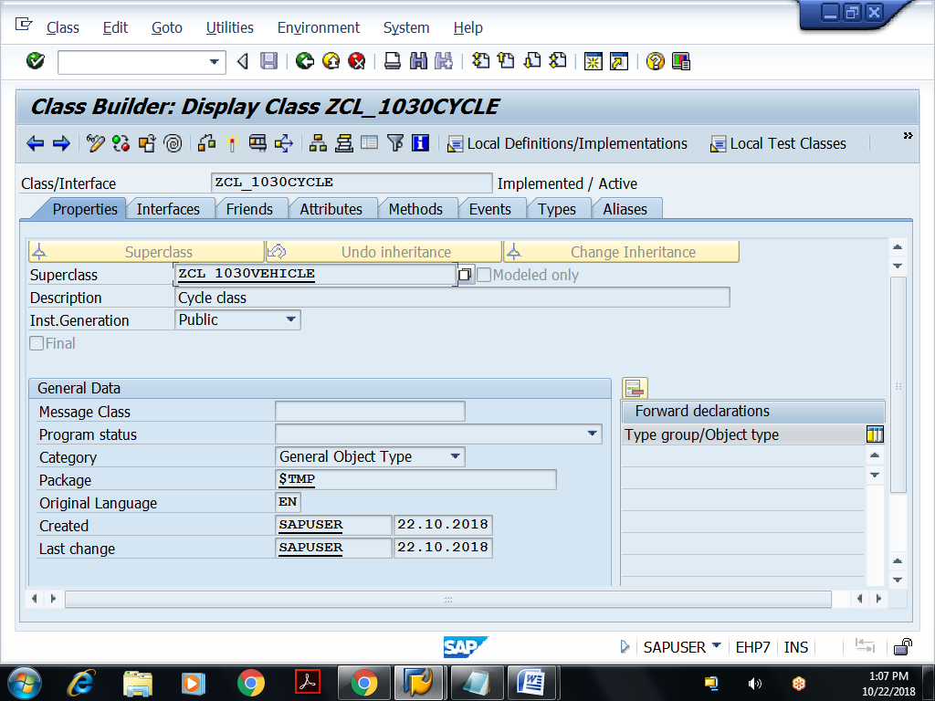
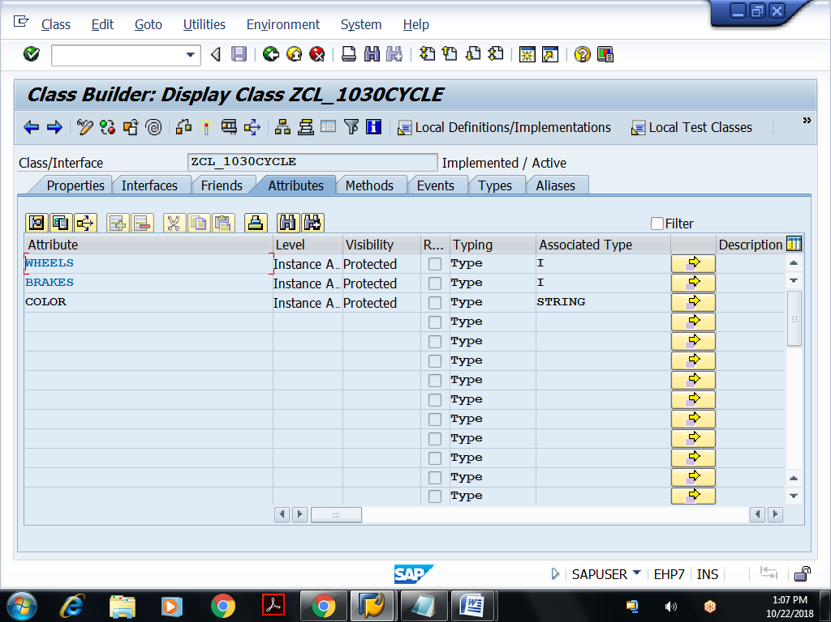
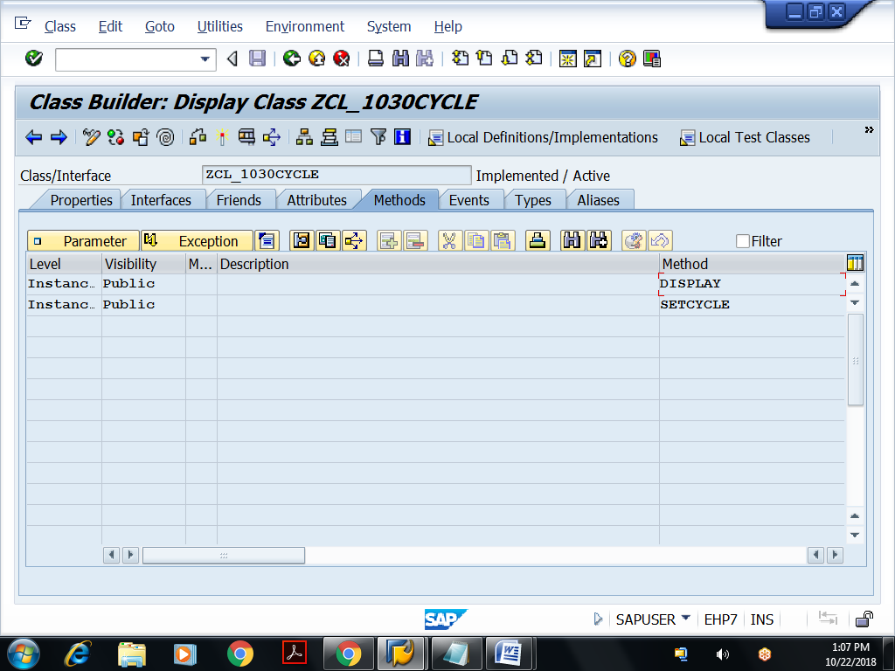
Implementation for Setcycle method
method SETCYCLE.
wheels = 2.
brakes = 2.
color = 'Green'.
endmethod.
Redefine ‘Display method’:
method DISPLAY.
CALL METHOD SUPER->DISPLAY.
write :/ color.
endmethod.

Save, check and activate
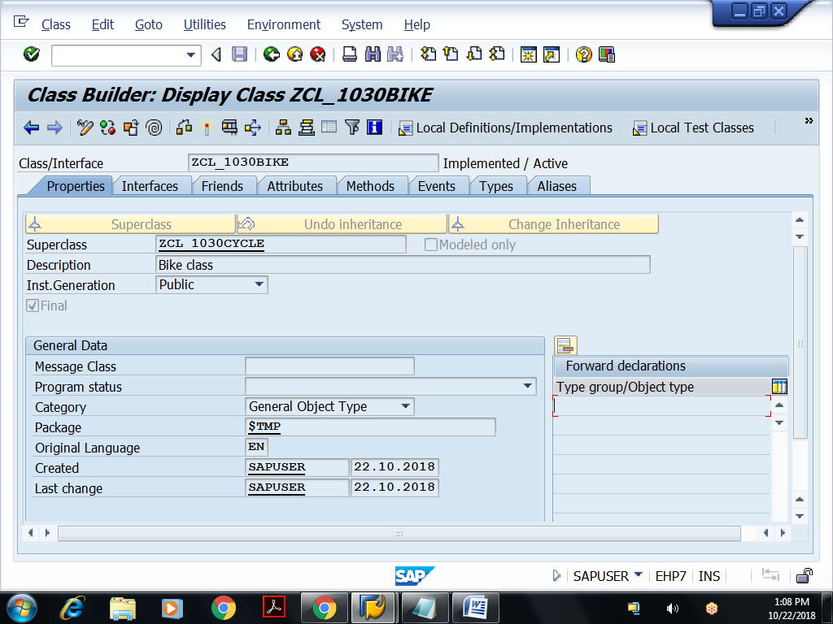
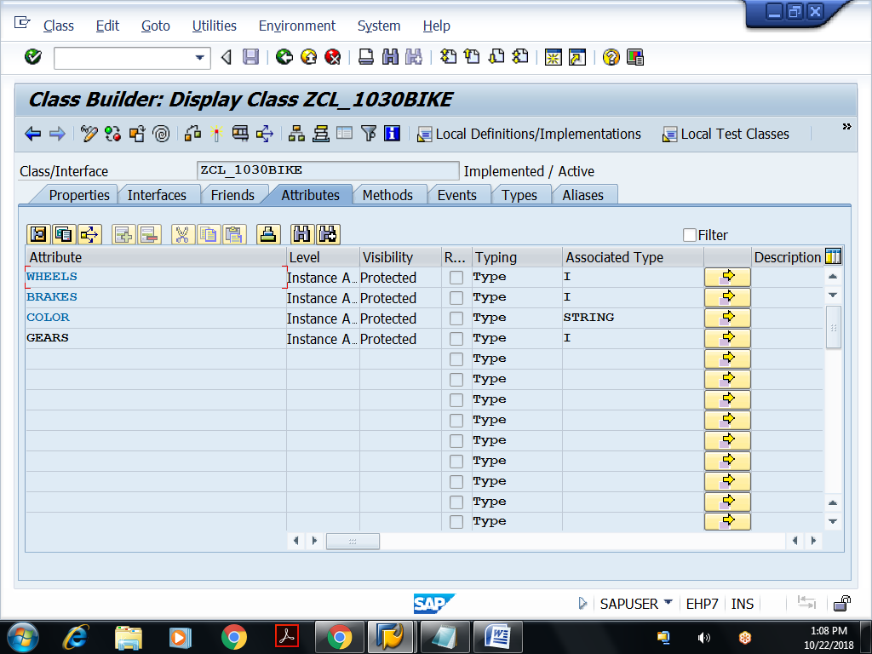
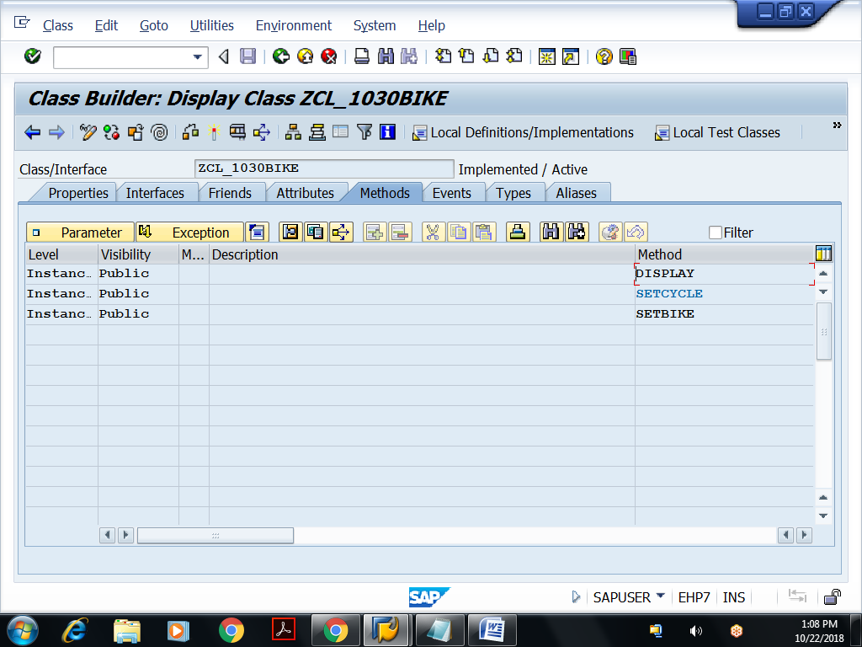
Implementation for SETBIKE method:
method SETBIKE.
wheels = 2.
brakes = 2.
color = 'Red'.
gears = 5.
endmethod.
Redefine Display method
method DISPLAY.
CALL METHOD SUPER->DISPLAY.
write :/ gears.
endmethod.
Save, check and activate
Executable program: For accessing above global classes
REPORT Z1030OOPS16.
write :/ '....CYCLE class object ob....'.
data ob type ref to zcl_1030cycle.
create object ob.
call method ob->setcycle.
call method ob->display.
uline.
write :/ '....BIKE class object ob1....'.
data ob1 type ref to zcl_1030bike.
create object ob1.
call method ob1->setbike.
call method ob1->display.

